PROJECT REPORT DEMONSTRATION
1 INTRODUCTION
OVERVIEW
Designing A Certificate Using Canva
The Creating of designing visually appealing of certificate for a debate for college programme using canva the project focus on developing visually enhancing and designing certificate to enhance the quality effectiveness of college programme.
PURPOSE
The Project assigned that the skills of using technology to create the designing certificate using Canva with help of canva application
2. PROBLEM DEFINITIONS AND DESIGNIN THINKING
EMPATHY MAP

BRAINSTORMING MAP
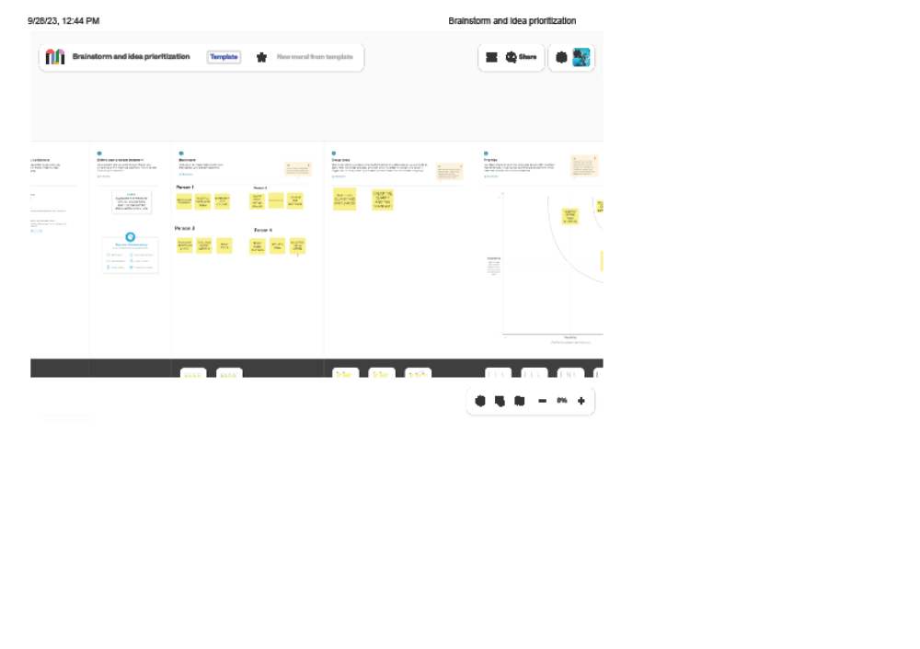
3. RESULTS
PROJECT NAME: DESIGNING VISUALLY APPEALING CERTIFICATE FOR A DEBATE USING CANVA
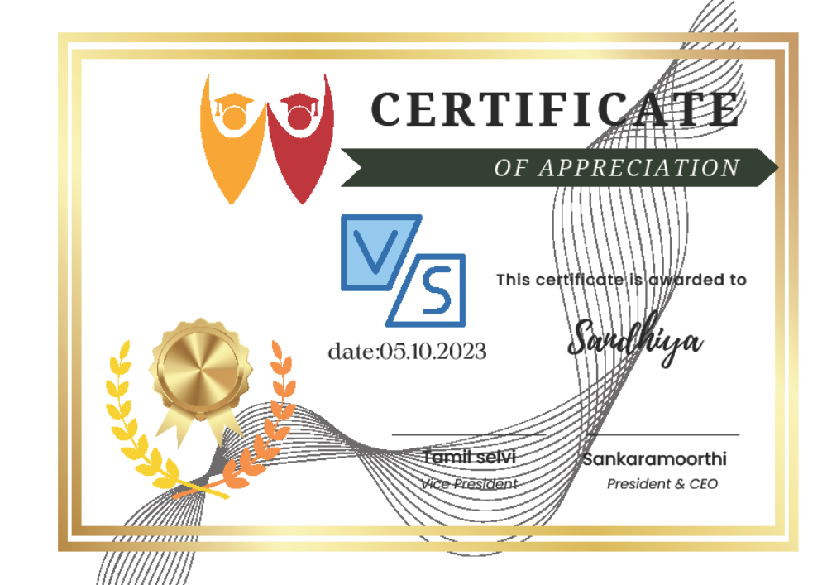

4. ADVANTAGES AND DISADVANTAGES
. ADVANTAGES | DISADVANTAGES
- It is used effectively in creating a project  - It is economical  - It is User-Friendly  - In Canva There are a lot of activities for designing | 1.Some logo ,images, designs are so costly  2. E-mail Id is mandatory

5. APPLICATION
THE CANVA Application is very useful to create my project easily. It helps with new templates .
It will be useful in my future projects.
6. CONCLUSION
In NAAN MUDHALVAN SCHEME I am a student in Sri Ramanas College of Arts and Science for Women in chidambarapuram, assigned my project to be done with help of Canva Application. I have learned that usage of canva App well and It is very user-friendly.

